**Batch: H3 - 3**

**Roll No.: 16014022050**

**Experiment No. 8**

|  |
| --- |
| **TITLE: To perform NLP on clinical data** |

**AIM:** Named Entity Recognition on Healthcare Data

**Expected OUTCOME of Experiment:**

**CO5:** Apply data analytics in the field of Health care.

**_____________________________________________________________________**

**Books/ Journals/ Websites referred:**

**_____________________________________________________________________**

**Pre Lab / Prior Concepts:**

Students should have a basic understanding of natural language processing concepts like named entity recognition.

**Procedure:**

**Data set Used: Pretrained spaCy model**

**Step 1: Installed required library**

*# Step 1: Install required library*

!pip install spacy

!python -m spacy download en_core_web_sm

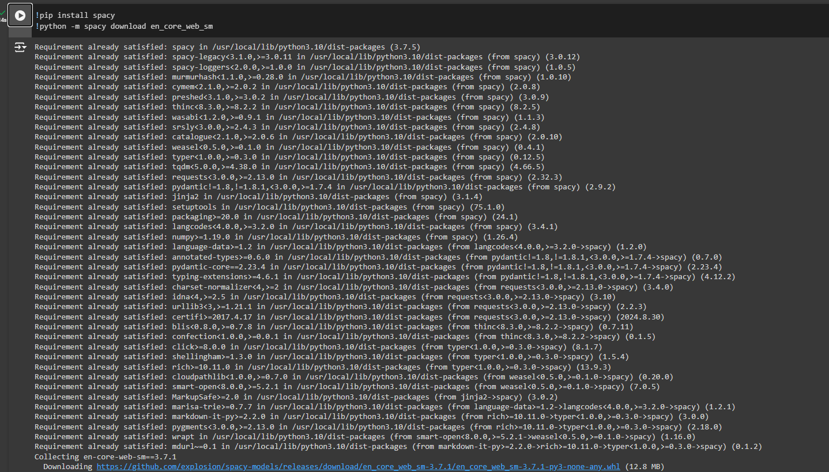

**Step 2: Load pretrained spaCy model**

*# Step 2: Load pretrained spaCy model*

import spacy

nlp = spacy.load('en_core_web_sm')



**Step 3: Add Sample healthcare-related text**

*# Step 3: Add Sample healthcare-related text*

healthcare_text = """

Dr. Smith prescribed 500mg of Amoxicillin to treat the patient's bacterial infection at Mount Sinai Hospital.

The patient reported experiencing fever of 101°F and severe headache for the past 3 days.

The blood pressure reading was 120/80 mmHg, and the heart rate was 85 BPM.

"""

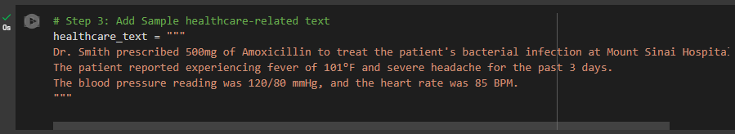

**Step 4: Process Text**

*# Step 4: Process Text*

doc = nlp(healthcare_text)



**Step 5: Print named entities**

# Step 5: Print named entities

for ent in doc.ents:

    print(f"Entity: {ent.text}")

    print(f"Label: {ent.label_}")

    print(f"Label Description: {spacy.explain(ent.label_)}")

    print("-" * 50)

# Expected output will look similar to this:

"""

Entity: Dr. Smith

Label: PERSON

Label Description: People, including fictional

"""

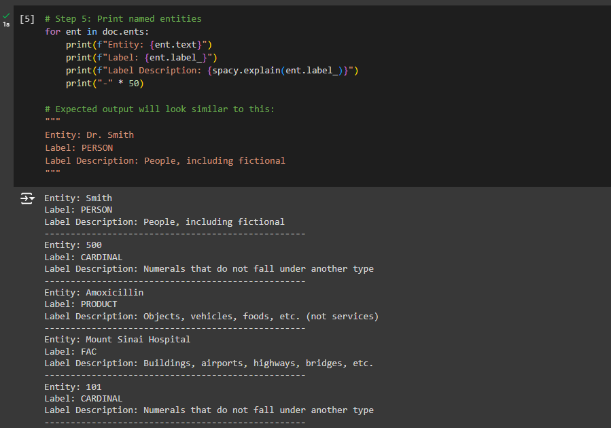

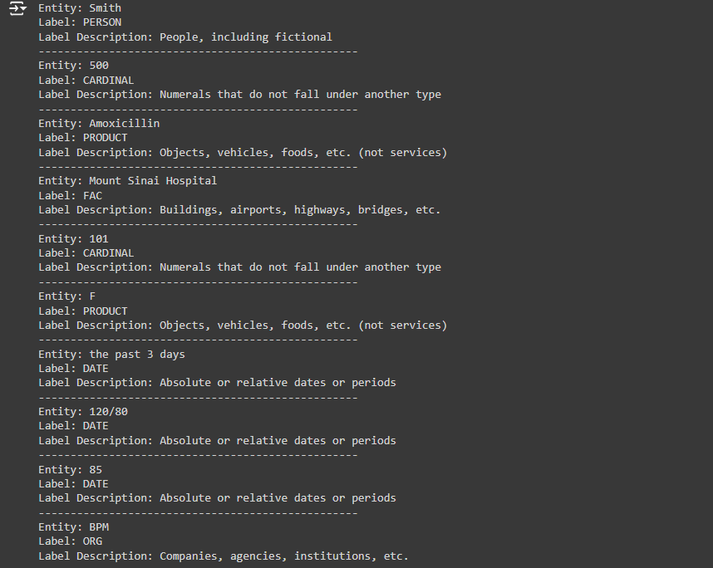

**Implementation Details:**

***# Step 1: Install required library***

**!pip install spacy**

**!python -m spacy download en_core_web_sm**

***# Step 2: Load pretrained spaCy model***

**import spacy**

**nlp = spacy.load('en_core_web_sm')**

***# Step 3: Add Sample healthcare-related text***

**healthcare_text = """**

**Dr. Smith prescribed 500mg of Amoxicillin to treat the patient's bacterial infection at Mount Sinai Hospital.**

**The patient reported experiencing fever of 101°F and severe headache for the past 3 days.**

**The blood pressure reading was 120/80 mmHg, and the heart rate was 85 BPM.**

**"""**

***# Step 4: Process Text***

**doc = nlp(healthcare_text)**

***# Step 5: Print named entities***

**for ent in doc.ents:**

**print(f"Entity: {ent.text}")**

**print(f"Label: {ent.label_}")**

**print(f"Label Description: {spacy.explain(ent.label_)}")**

**print("-" * 50)**

***# Expected output will look similar to this:***

**"""**

**Entity: Dr. Smith**

**Label: PERSON**

**Label Description: People, including fictional**

**"""**

**Date: _____________ Signature of faculty in-charge**

**Post Lab Descriptive Questions:**

1. **What is Natural Language Processing (NLP) and how is it applied to healthcare data?**

Natural Language Processing (NLP) is a branch of artificial intelligence focused on enabling computers to understand, interpret, and generate human language in a valuable way. It combines linguistics, computer science, and AI to analyze unstructured text data, identify patterns, and extract useful information from it.

In healthcare, NLP is applied to analyze large volumes of clinical text data, such as medical records, physician notes, research papers, and radiology reports. Some key uses include:

* Information Extraction: Identifying symptoms, diagnoses, medications, or treatment details from patient notes.
* Data Structuring: Converting unstructured text into structured data, helping in patient profiling and treatment planning.
* Predictive Modeling: Analyzing patient histories and predicting disease risks by extracting relevant data points.
* Clinical Research: Automatically reviewing medical literature, supporting drug discovery, and identifying emerging healthcare trends.

1. **What are named entities in the context of healthcare NLP, and how can Named Entity Recognition (NER) be useful in medical texts?**

Named entities in healthcare NLP refer to specific terms or concepts such as patient names, medical conditions, symptoms, drug names, anatomical parts, and procedures. Recognizing these entities is essential because they hold critical, context-specific information.

Named Entity Recognition (NER) is an NLP technique that identifies and categorizes these entities within texts, which can help:

* Extract Key Medical Information: NER helps to automatically identify important data like disease names, medications, and treatment dates in patient records.
* Summarize Clinical Notes: Extracting entities makes it easier to summarize lengthy medical notes for quick reference.
* Enhance Clinical Decision Support: By structuring information through NER, healthcare providers can retrieve relevant patient information more easily and make informed decisions.

1. **What are some common applications of NLP in healthcare, such as clinical decision support, medical coding, or patient sentiment analysis?**

* Clinical Decision Support: NLP extracts and synthesizes patient data from unstructured text to help healthcare providers make data-informed treatment decisions, flag risks, and suggest possible interventions.
* Medical Coding and Billing: NLP helps in automating the coding of clinical data by extracting diagnostic codes from physician notes, which improves billing efficiency and accuracy.
* Patient Sentiment Analysis: Analyzing patient feedback and comments to understand their satisfaction, concerns, and emotional health, helping improve patient experience.
* Electronic Health Records (EHR) Management: NLP tools structure and organize data in EHRs, making it easier for clinicians to retrieve relevant information, reducing time spent on record keeping.
* Drug Discovery and Research: NLP analyzes scientific literature to identify potential drug interactions, side effects, and treatment outcomes, accelerating drug discovery processes.